CALENDRIER DIVISION INTER-REGIONS SAISON : 2024-2025
GROUPE « OUEST »
IST-USR | ICST-Es Senia |  | IRBT-OSBA |  | JSB-JSEA | SCMO-CASA | RCR-IRBEK | USMBA-FCBT | WAT-EST
IST-SCMO | FCBT-EST |  | IRBEK-USMBA |  | CASA-WAT | JSEA-RCR | OSBA-JSB | Es-Senia-IRBT | USR-ICST
EST-IRBEK | ICST-IST |  | IRBT-USR |  | JSB-Es-Senia | SCMO-JSEA | RCR-OSBA | USMBA-CASA | WAT-FCBT
IST-IRBT | ICST-SCMO |  | IRBEK-FCBT |  | CASA-EST | JSEA-USMBA | OSBA-WAT | Es-Senia-RCR | USR-JSB
EST-JSEA | FCBT-CASA |  | IRBT-ICST |  | JSB-IST | SCMO-Es-Senia | RCR-USR | USMBA-OSBA | WAT-IRBEK
IST-RCR | ICST-JSB |  | IRBT-USMBA |  | CASA-IRBEK | JSEA-FCBT | OSBA-EST | Es-Senia-WAT | USR-SCMO
EST-IST | FCBT-ICST |  | IRBEK-JSEA |  | JSB-IRBT | SCMO-OSBA | RCR-CASA | USMBA-Es-Senia | WAT-USR
IST-WAT | ICST-RCR |  | IRBT-SCMO |  | JSB-USMBA | JSEA-CASA | OSBA-IRBEK | Es-Senia-FCBT | USR-EST
EST-Es Senia | FCBT-USR |  | IRBEK-IST |  | CASA-OSBA | SCMO-JSB | RCR-IRBT | USMBA-ICST | WAT-JSEA
ISTF-CBT | ICST-EST |  | IRBT-WAT |  | JSB-RCR | SCMO-USMBA | OSBA-JSEA | Es-Senia-CASA | USR-IRBEK
EST-IRBT | FCBT-OSBA |  | IRBEK-Es Senia |  | CASA-JSB | JSEA-IST | RCR-SCMO | USMBA-USR | WAT-ICST
IST-CASA | ICST-IRBEK |  | IRBT-FCBT |  | JSB-EST | SCMO-WAT | RCR-USMBA | Es-Senia-OSBA | USR-JSEA
ESTS-CMO | FCBT-JSB |  | IRBEK-IRBT |  | CASA-ICST | JSEA-Es-Senia | OSBA-USR | USMBA-IST | WAT-RCR
IST-OSBA | ICST-JSEA |  | IRBT-CASA |  | JSB-IRBEK | SCMO-FCBT | RCR-EST | USMBA-WAT | USR-Es-Senia
EST-USMBA | FCBT-RCR |  | IRBEK-SCMO |  | CASA-USR | JSEA-IRBT | OSBA-ICST | Es-Senia-IST | WAT-JSB

01 |   E.S.Tighennif | 02 |   I.S.Tighennif | 03 | 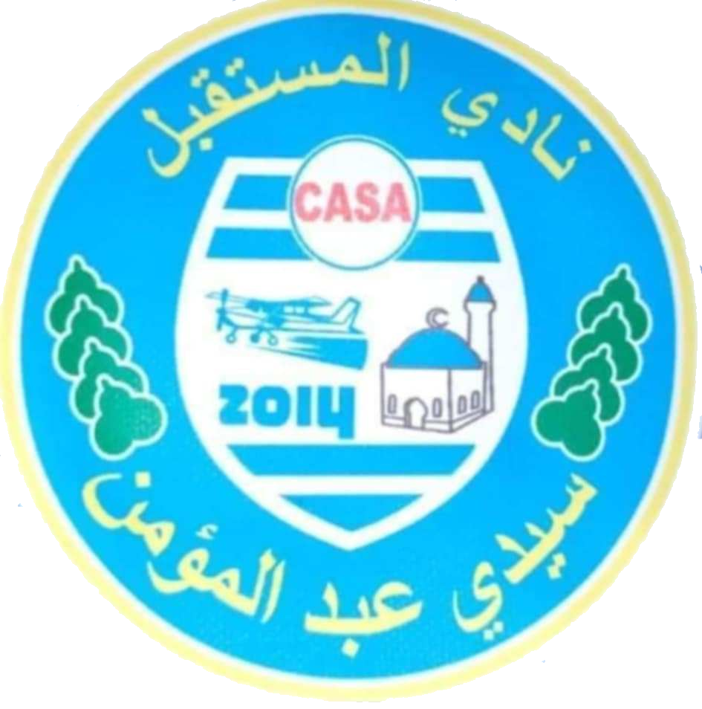  C.A.S.Abdelmoumen | 04 |   F.C.B.Telagh | 05 | I.C.S.Tlemcen
06 | 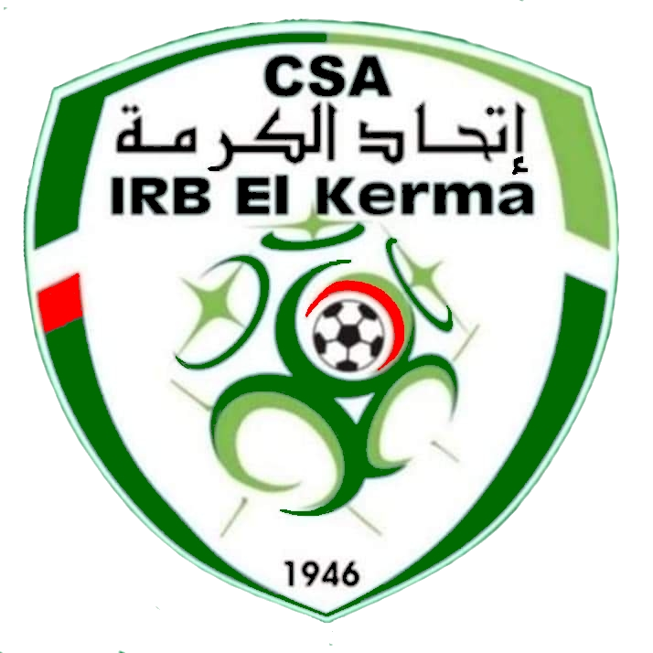  I.R.B.El Kerma | 07 | I.R.B.Tiaret | 08 | J.S.Bendaoud | 09 |   J.S.Emir Abdelka | 10 | S.C.M.Oran
11 | Nasr Es-Senia | 12 |   O.Sidi Ben Adda | 13 | R.C.Relizane | 14 |   U.S.M.Bel Abbes | 15 |   U.S.Remchi
 |  |  |  | 16 | W.A.Tlemcen
La Première Variante

